Accessibility Guide for Connell Outdoor Pursuits
info@connelloutdoorpursuits.com, +447341318151, www.connelloutdoorpursuits.com
Contact for accessibility enquiries: Kurt Connell
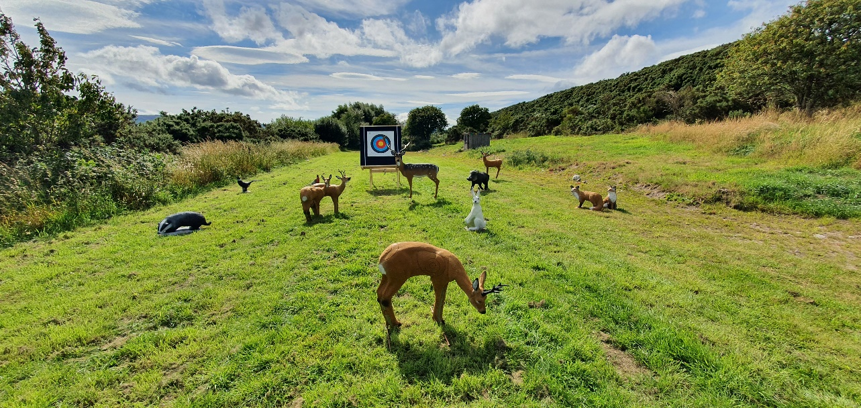

Welcome
Connell Outdoor Pursuits is based near Dornoch on the east coast of Sutherland, right on the world famous North Coast 500 route, and also operates in various locations across the stunning Scottish Highlands.
Whether you are looking to enjoy an archery session, test your aim with clay shooting, take a nocturnal thermal imaging tour, or fish in our cool, clean waters, Connell Outdoor Pursuits will tailor your experience to your ambitions and ability, guaranteeing a great day out.
This accessibility guide is for our outdoor archery range near Dornoch. For full accessibility details of other activities and locations please contact Connell Outdoor Pursuits through the contact details above.
Get in touch if you require any further information about specific access or need advice on planning your visit.
At a Glance
Level Access
- There is level access from the car park to the archery range.

Hearing
- There is no hearing loop system currently in place.

Visual
- Archery targets use a range of high-contrasting colours.

General
- Activity instruction is given through both verbal and visual demonstrations.

Getting here
Connell Outdoor Pursuits
Sydera Croft
Lonemore
Dornoch
IV25 3RW

- Link to Google Maps location
- What3Words: condiment.relations.affords

Travel by public transport
- There is no public transport currently to Connell Outdoor Pursuits.

Travel by taxi
- You can book a taxi locally with Mackay’s Taxis by calling 01862 810162.

Parking
- There is a dedicated gravel car park on site with level access to the archery range.
- There is parking space for 8-10 vehicles in the on site car park. There is no other parking nearby.
- There is no lighting available in the car park.

[Pic of car park]
Connell Outdoor Pursuits car park

Arrival
Car park to archery range
- The car park and archery range are an open plan site on level ground. The car park and shooting area is packed gravel, while the range is trimmed grass.
- The car park is on site with the archery range so there is no distance to travel between them.
- There is a short steep sloped driveway entrance to the car park so care should be taken in vehicles on arrival and departure.

[Pic of archery range]
View of archery range

[Pic of driveway slope]
View of driveway entrance to car park

On-site amenities
Public toilet
- There are no public toilet facilities available to visitors on site at the archery range.
- The nearest public toilets are in Dornoch, approximately 8 mins drive from the archery range.

Seating
- There are several picnic bench and single bench seating options provided at the archery range.

Customer care support
Accessibility equipment
- We welcome assistance dogs provided they are able to be leashed for the duration of the activity, for their safety.
- Please ask staff for assistance with the nearest toilet area for assistance dogs.

Archery instruction
- Our staff will do everything possible to assist you with safe and enjoyable instruction tailored to your abilities and experience. For any specific enquiries or requirements related to accessibility please contact us.

Guide last updated: 24 November 2023

